X551MA win7 setting SOP
- Enter SETUP.
- Find Security ,enter Secure Boot menu.
- Set Secure Boot to Disable
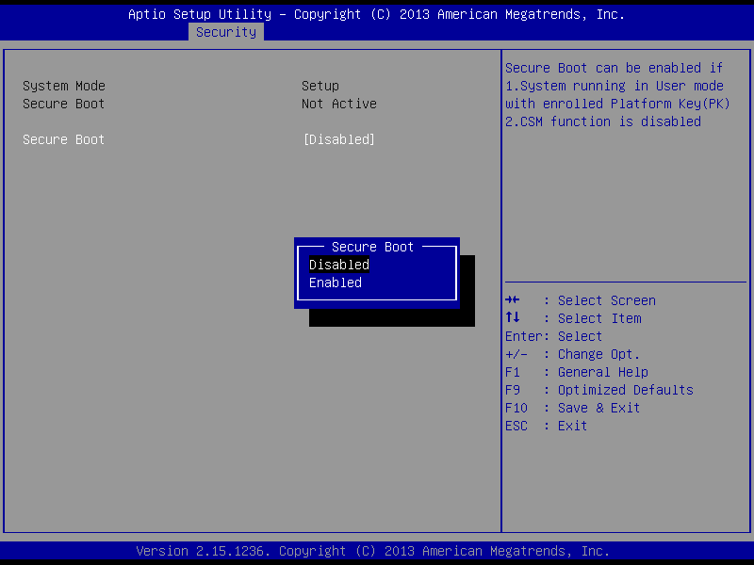

4.Find Launch CSM in Boot.
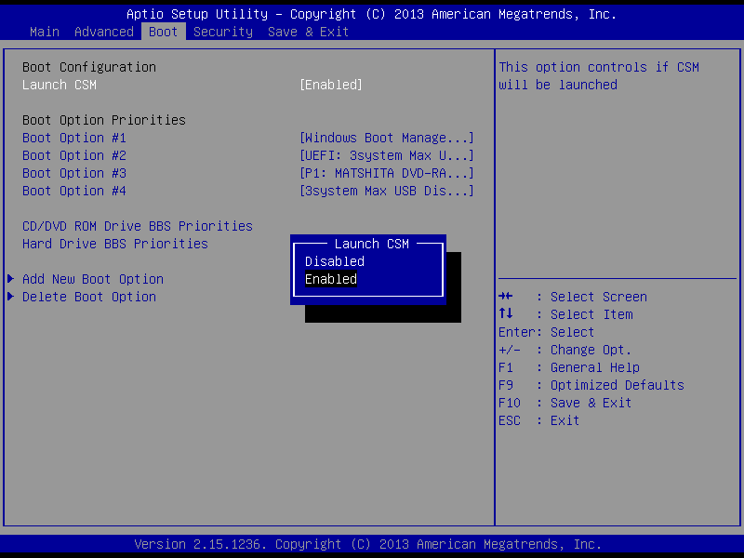

5.Set Lauch CSM to ENABLE.

6.Find OS Selection
7.Set to WIN 7.
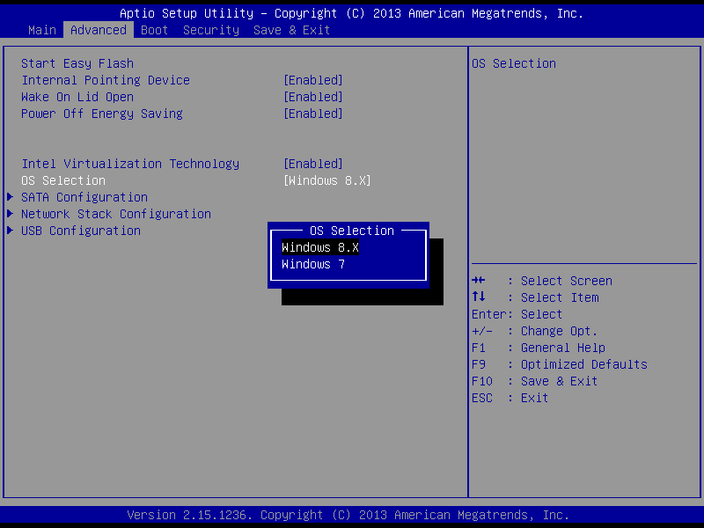

8.Press F10,save and exit.
9.Install WIN7.

